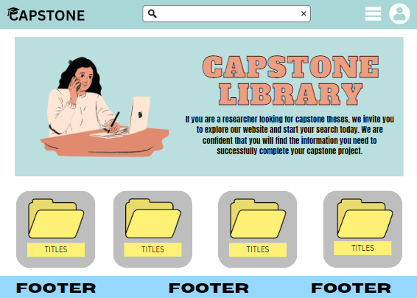

Home page of student

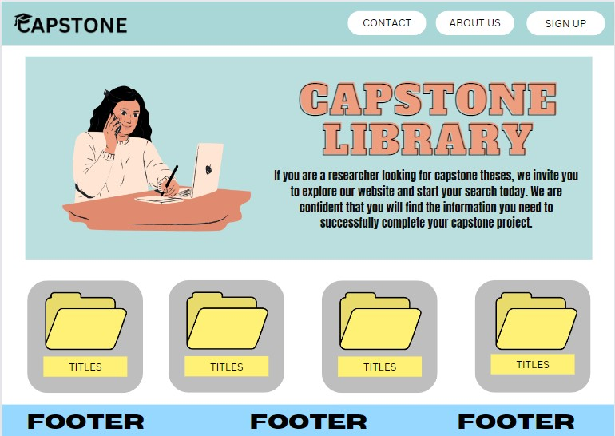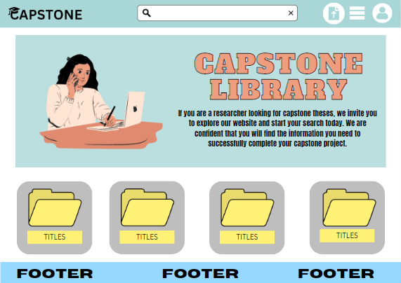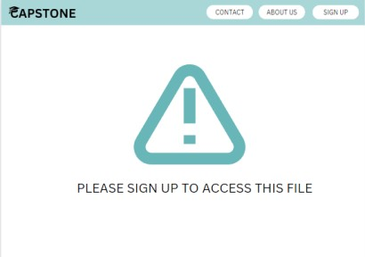

Home page of teachers

KAPAG PININDOT YUNG FILE TAPOS DI PA NAKA SIGN IN HETO LALABAS

LANDING PAGE

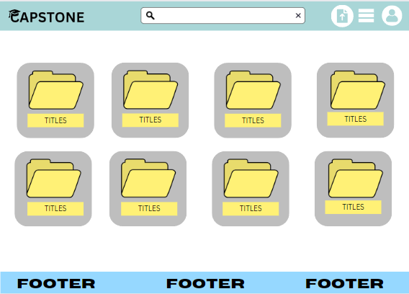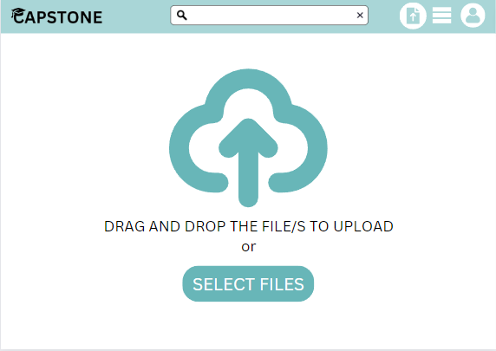

KAPAG NI_CLICK YUNG FILE HETO LALABAS

RESULT PAGE KAPAG NAG SEARCH YUNG USER HETO LALABAS BUT IF WALA TEXT SAYING NA WALANG RESULTS

UPLOAD PAGE

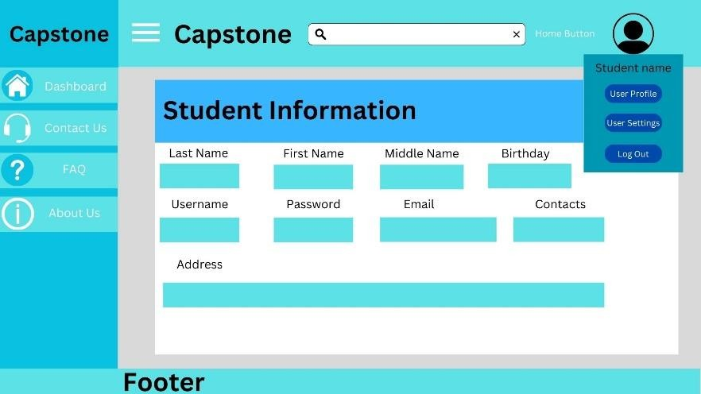

USER PROFILE

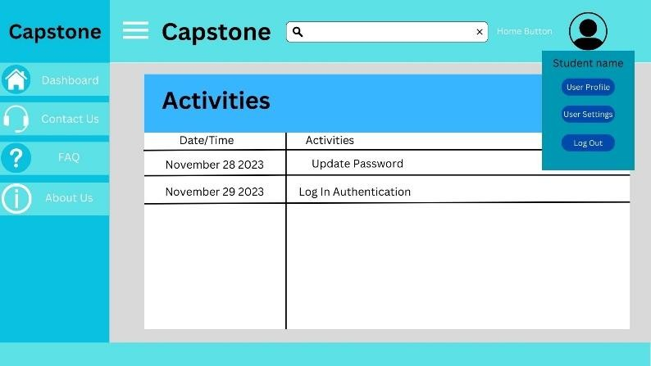

AUDIT TRAIL

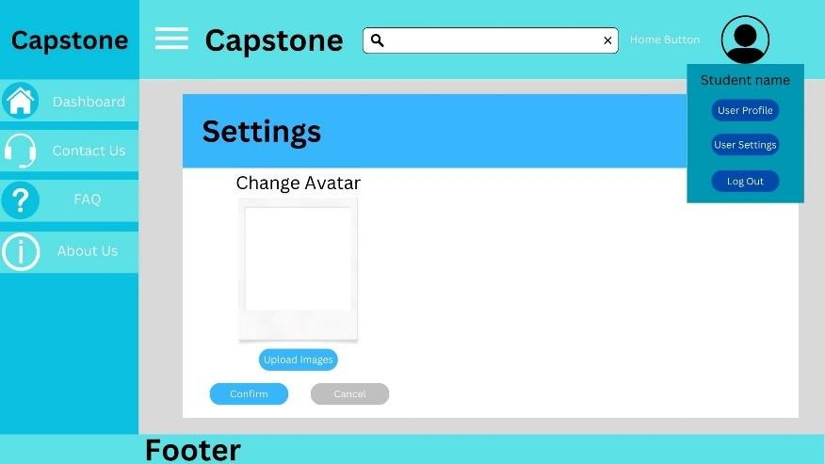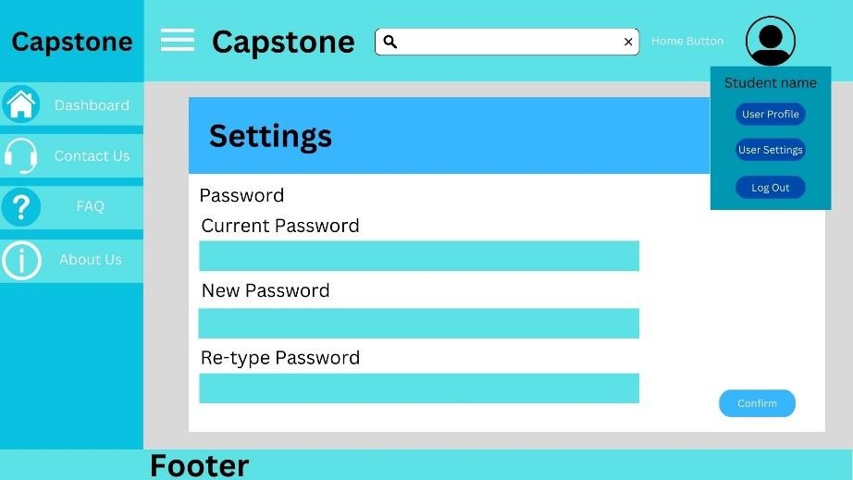

USER UPADTE OR SETTINGS 2

USER UPADTE OR SETTINGS 1

LOG IN for students

and teachers and admin

registration



Header – may upload button

Kapag mag uupload dapat hindi na tatanggapin kung existing na

Audit trail of student

Audit trail of Teacher

Delete or update of users and capstones.

admin

Upload page

Pag pinindot yung file lalabas yung laman ng file

Pag pinindot yung file lalabas yung laman ng file

---User settings---- User Info Update User Info

Audit Trail

–date time – Activities

Result page

Result page

LANDING PAGE

|  |  |  |  |  |  |
| --- | --- | --- | --- | --- | --- |
|  | student |  | | teacher |  |
| Homepage – can | | | Homepage – can | | |
| search the capstones | | | search the capstones | | |
| uploaded in the | | | uploaded in the | | |
| website | | | website and can | | |
|  | | | upload files in the | | |
| website | | |

Gallery of uploaded capstones

User settings User Info Update User Info

Audit Trail

–date time – Activities